1. Click new/Edit test button, then click any settings tab and click back button and again click add/edit test button previously selected setting tab is displayed. It needs to display the “Basic Settings” tab. -(Done)-PASS
2. In Test page, test created person name is not displayed and it was empty. -(Done)-PASS
3. In basic settings, after enter valid details and click save button, tab should immediately move to next tab (Question manager tab), but it only moves after the pop up is closed. -(Done)-FAIL -(Done)-PASS
4. In question manager, after add a topic and click delete button, Text needs to change as “Are you sure want to delete this question from question manager?” or any other valid message. And also need to improve the size of the text and the text should present in a single line only. -(Done)-FAIL-Need to change the message as “Are you sure want to delete this Topic from Question Manager?” -(Done)-PASS
5. In question manager, after add a topic and click delete button, Heading should need to change as “Delete topic” not as “Delete question setup”. -(Done)-PASS
6. In question manager, in topics, all details are aligned in left side, need to align in center both heading and content. -(Done)-FAIL -(Done)-PASS
7. In question manager, after enter valid details and click save button and again redirect to question manager, time values are displayed as zero. -(Done)-FAIL -(Done)-PASS
8. In Time setup, after enter valid details and click save button, “Something went wrong” error pop up is displayed. -(Done)-FAIL -(Done)-PASS
9. In Test Access, all details are aligned in center, but proctor details are displayed as left alignment and need to change into center alignment. -(Done)-PASS
10. In Test Access, in second column heading name need to change as “Candidate name” current name is “User Name”. -(Done)-PASS
11. In Certificate template, need to improve the alignment. -(Done)-PASS
12. In certificate template, Advanced programming test name should change as selected category name. -(Done)-PASS
13. In Question manager, in time tab need to mention the format and unit. -(Done)-PASS
14. In Test setup, extra space is displayed. -(Done)-PASS

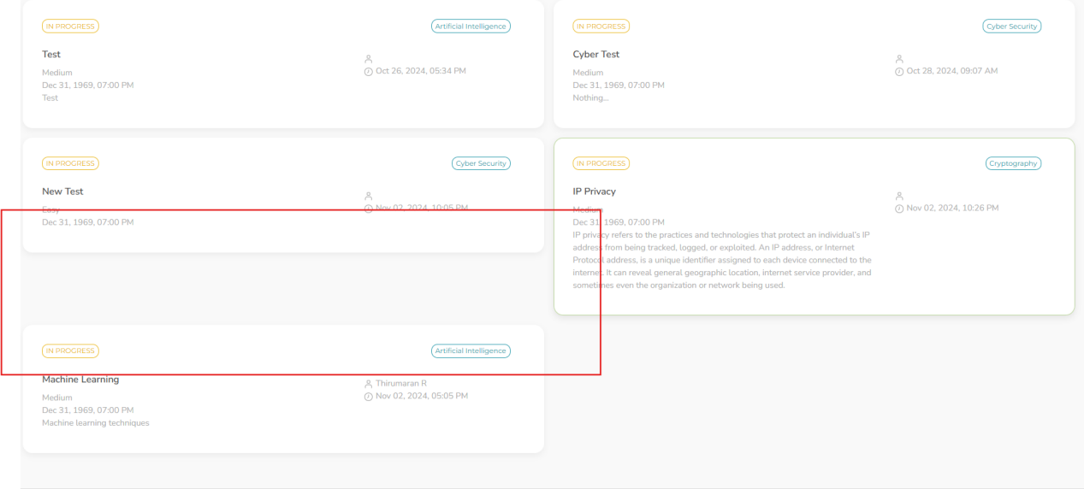

1. In Question manager, after enter valid details and click clear button, in add topics, topic value is not cleared. -(Done)-FAIL (Need to remove the added topics and topic option in the dropdown). (Done)-PASS

**New Bugs (04-11-24)**:

1. After save in Basic settings with valid details, “Tick” symbol is not enabled. -(Done)-PASS
2. After save in QUESTION MANAGER with valid details, success message is displayed and it moves to next tab “Time Setup” but question manager tab is disabled automatically. -(Done)-PASS
3. After save in QUESTION MANAGER with valid details, success message is displayed but message is wrong it needs to show “Question manager updated successfully!”. -(Done)-PASS
4. In Time setup, remove the pre-defined text format in the test time text box. -(Done)-PASS

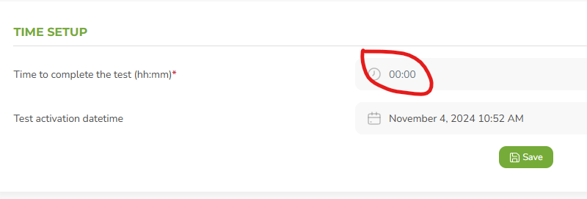

1. In Time setup, change the test activation text format into “Test activation date & time”. -(Done)-PASS

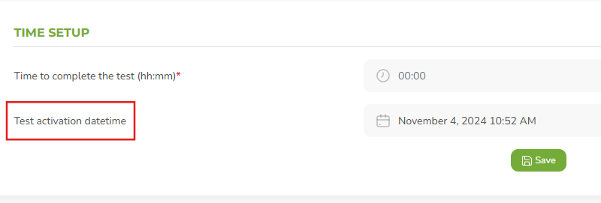

1. In Time setup, test time cannot able to enter properly. Double colon is automatically appeared. -(Done)-PASS

